Wireshark Lab: ICMP
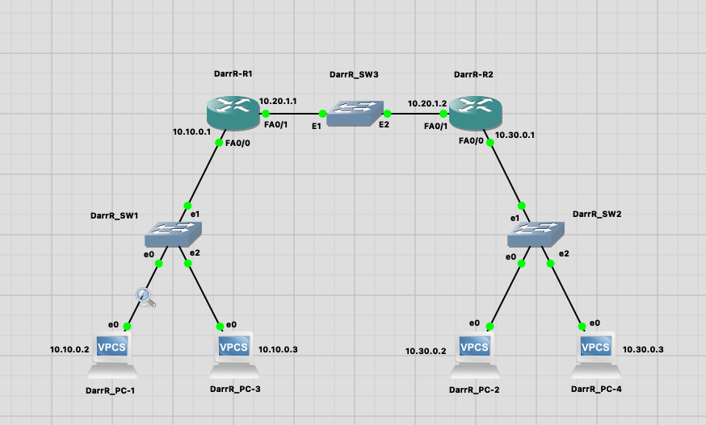

1) Create a similar topology. Rename all the routers as per the format given in topology above.
2) Connect all the links as shown and configure the given IP addresses.
3) Configure static routes on routers R1 and R2.
All the configurations to be done in global config mode of routers.

In this lab, we’ll explore several aspects of the ICMP protocol:
- ICMP messages generating by the Ping program;
- ICMP messages generated by the Traceroute program;
- the format and contents of an ICMP message.

1. ICMP and Ping
Do the following:
- Configure a static route on R1 to reach 10.30.0.0 network. Also configure a static route on R2 t reach 10.10.0.0 network.
- Start a Wireshark capture on link between PC-1 and Switch-1
- Ping from PC-1 to PC-4
- When the Ping program terminates, stop the packet capture in Wireshark.

What to Hand In:
Submit screen shots for successful ping result from PC-1 to PC-4 and Wireshark output displaying the packets captures during ping.
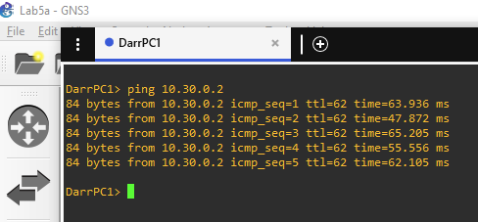
Figure: Ping result from PC-1 to PC-2

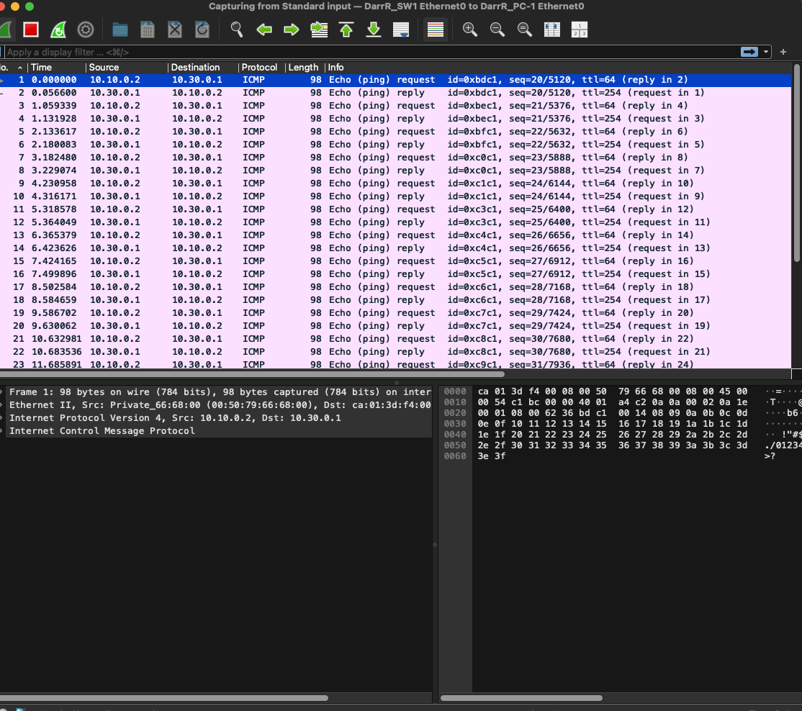
Figure: Wireshark output for Ping program with Internet Protocol.
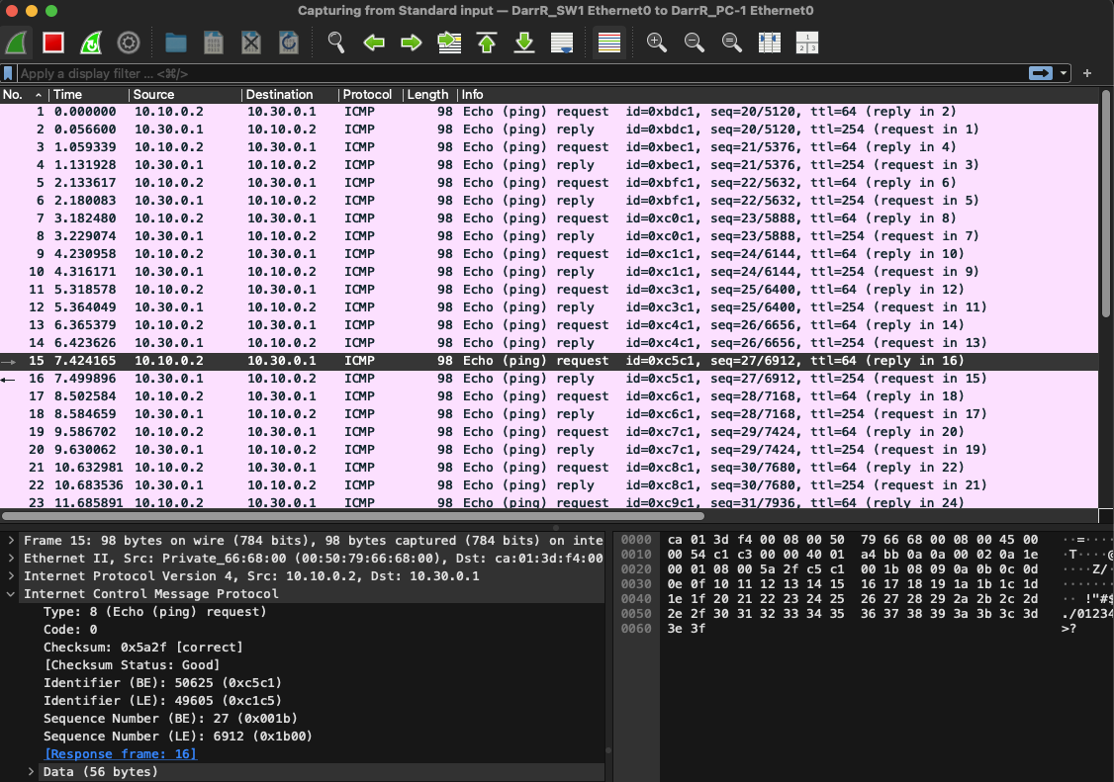
Figure: Wireshark capture of ping packet with ICMP packet expanded.

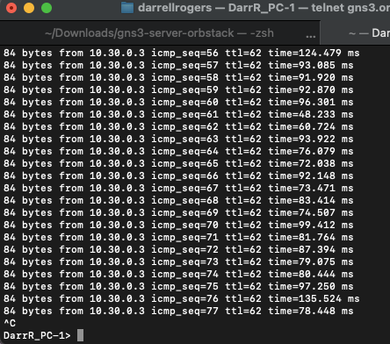
Figure: Ping result from PC-1 to PC-4

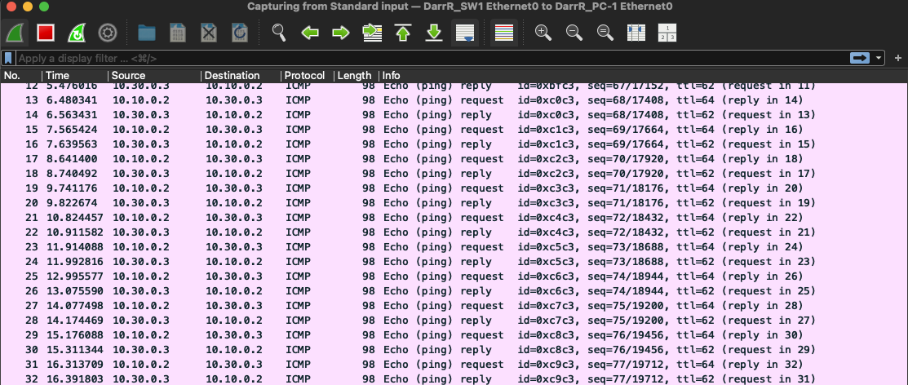
Figure: Wireshark result from PC-1 to PC-4
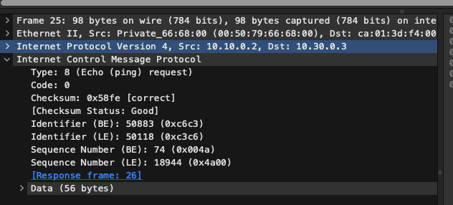
Figure: ICMP Packet

2. ICMP and Traceroute

At the end of the experiment, your Command Prompt Window should look something like Figure 4. In this figure, the client Traceroute program is in Massachusetts and the target destination is in France. From this figure we see that for each TTL value, the source program sends three probe packets. Traceroute displays the RTTs for each of the probe packets, as well as the IP address (and possibly the name) of the router that returned the ICMP TTL-exceeded message.

What to Hand In:

For this part of the lab, you should hand in a screen shot of the Command Prompt window. Whenever possible, when answering a question below, you should hand in a printout of the packet(s) within the trace that you used to answer the question asked. Annotate the printout to explain your answer. To print a packet, use File->Print, choose Selected packet only, choose Packet summary line, and select the minimum amount of packet detail that you need to answer the question.

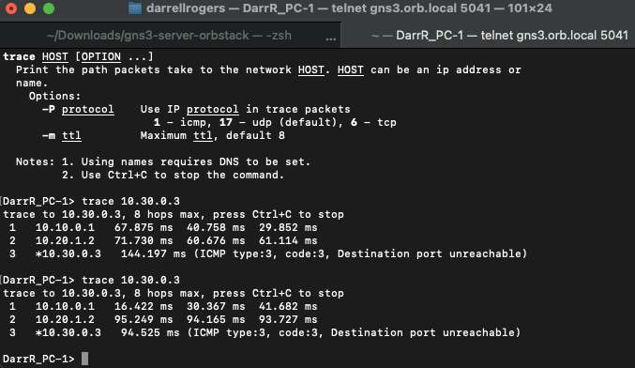
Figure: Command Prompt window displays the results of the Traceroute program.

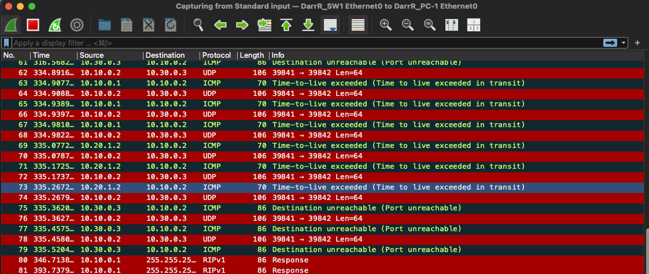
Figure: Wireshark window of ICMP fields expanded for one ICMP error packet.

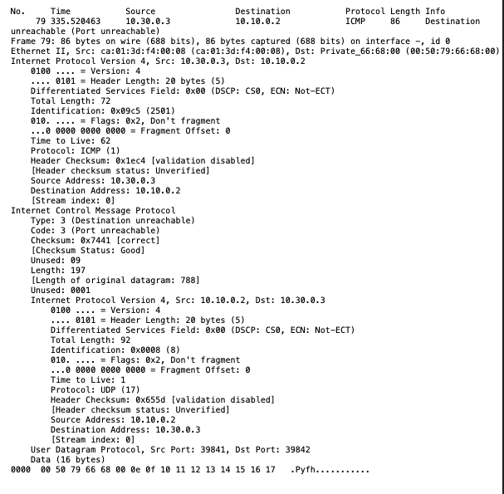
Figure: Error Packet

Answer the following questions:
- What is the IP address of your host? What is the IP address of the destination host?
  - 10.10.0.2 | 10.30.0.2
- Why is it that an ICMP packet does not have source and destination port numbers?
  - ICMP is a layer 3 protocol and not a transport layer protocol. It is not intended to be used to deliver data packets to applications.
- Examine one of the ping request packets sent by your host. What are the ICMP type and code numbers? What other fields does this ICMP packet have? How many bytes are the checksum, sequence number and identifier fields?
  - Type 8 Code 0
  - Checksum, Identifier and Sequence Numbers
  - Checksum: 2, Identifier: 2, Sequence number: 2.
- Examine the corresponding ping reply packet. What are the ICMP type and code numbers? What other fields does this ICMP packet have? How many bytes are the checksum, sequence number and identifier fields?
  - Type 0: Code 0
  - Checksum, Identifier and Sequence Numbers.
  - Checksum: 2, Identifier 2, Sequence Number: 2.
  - What is the IP address of your host? What is the IP address of the target destination host?
    - 10.10.0.2
    - 10.30.0.3
  - If ICMP sent UDP packets instead (as in Unix/Linux), would the IP protocol number still be 01 for the probe packets? If not, what would it be?
    - No, 17
  - Examine the ICMP echo packet in your screenshot. Is this different from the ICMP ping query packets in the first half of this lab? If yes, how so?
    - Yes; The ttl indicates an OS footprint using 64 as ttl, none are 254 as in the first half of the lab.
  - Examine the ICMP error packet in your screenshot. It has more fields than the ICMP echo packet. What is included in those fields?
    - Unused, Length, Length of original datagram.
  - Examine the last three ICMP packets received by the source host. How are these packets different from the ICMP error packets? Why are they different?
    - These are UDP Packets
  - Within the tracert measurements, is there a link whose delay is significantly longer than others? Refer to the screenshot in Figure 4, is there a link whose delay is significantly longer than others? On the basis of the router names, can you guess the location of the two routers on the end of this link?
    - In my case there was not.
    - Yes: P4-0.PASCR1.Pastourl.oprntransit.net
    - France

Lab Report

In my case, I spent the better part of 4 weeks setting up the lab so that I could complete this assignment. I created a total of 8 virtual machines, converted an older MacBook Pro 17” laptop to Ubuntu and setup a lab environment on my Mac Mini.

In each case I ran into issues. With my Mac Mini I eventually had to create a GNS3 server as a VM on my ESXi server and then run GNS3 client from my Mac Mine desktop that I connected to the GNS3 server.

I created a Windows 10 VM on my ESXi environment and attempted to run GNS3 stand-alone from there. For the most part it worked well except for not being able to isolate the Wireshark packet sniffing. I have yet to figure that out. I will likely try to connect the Windows machine to the newly created GNS3 server and run it as a client / server setup.

I also created an Ubuntu VM, a Fedora VM, two CentOS VM’s, a SUSA Linux VM, a Linux Mint Cinnamon VM and a Cisco CML server. In addition, I used a couple of different virtualization platforms on my Mac Mini and the Windows Server: VirtualBox and Orbstack.

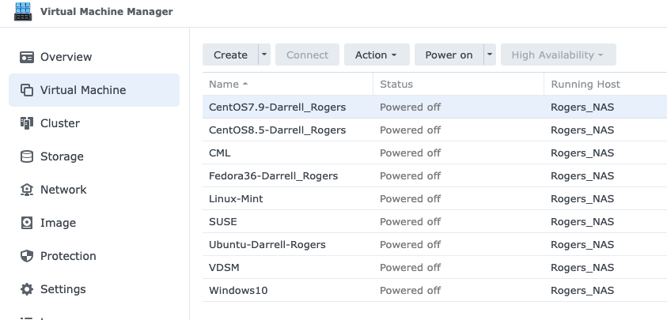

So, I have now tons of experience in setting up a lab environment on multiple platforms, physical and virtual. I plan on now utilizing them to learn all I can.
